- Download the Zomato Restaurants Kaggle dataset, load it into a pandas DataFrame, and display the first 5 rows along with info() and describe() output.
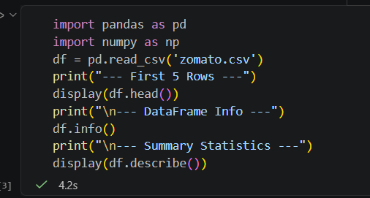

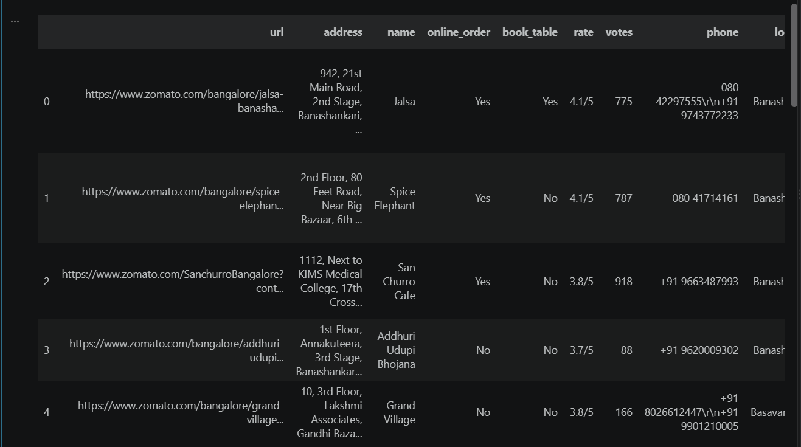

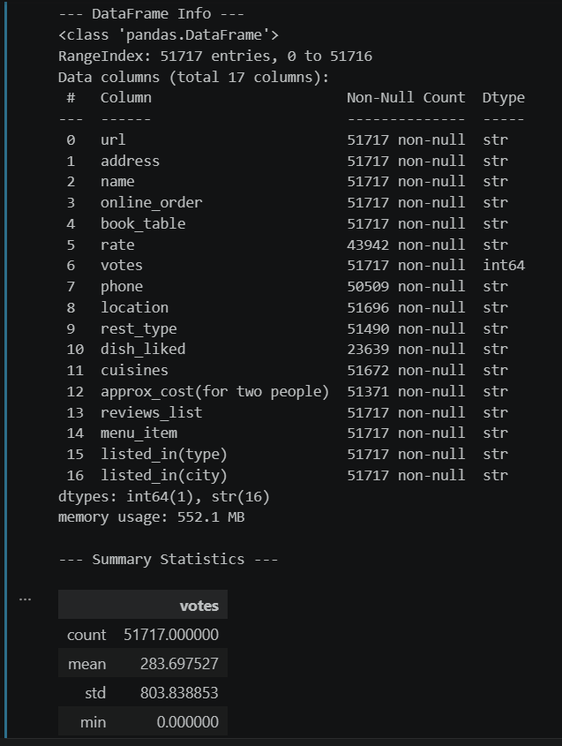

- Check the Zomato dataset for missing values and outliers in the 'cost' and 'rating' columns, and handle them appropriately using pandas and numpy. outliers, try using the IQR method or visualize with a boxplot.
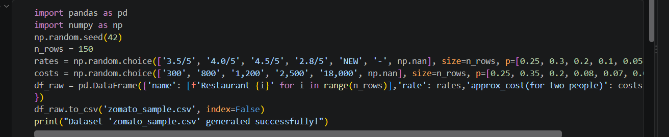

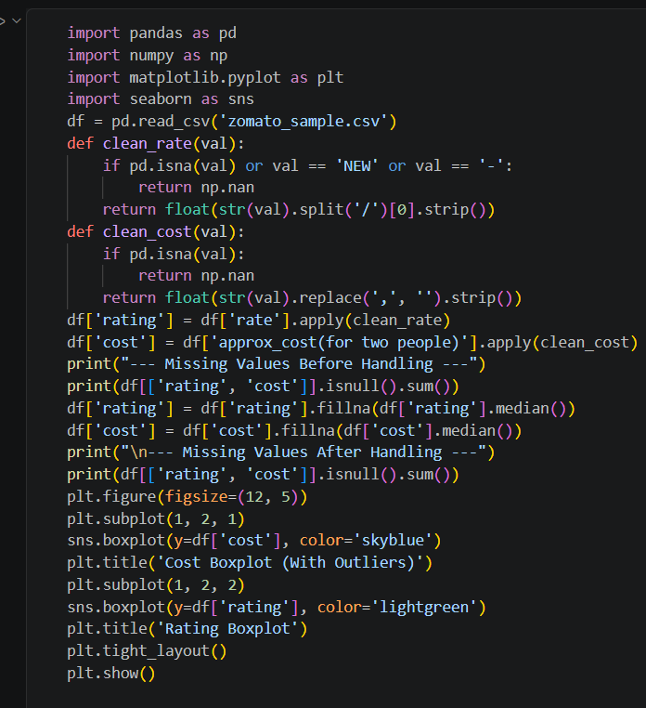

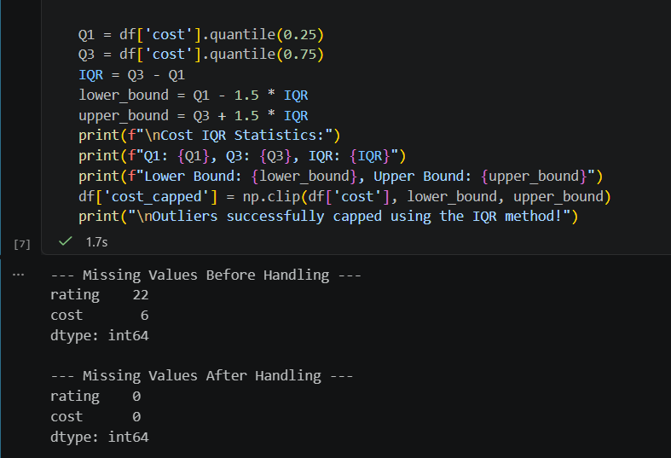

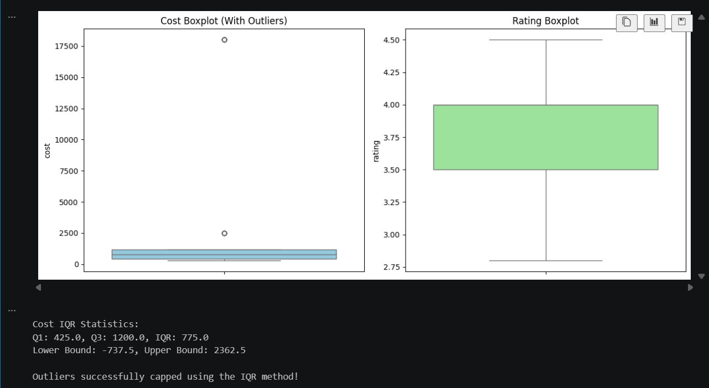

- Encode the 'cuisine' and 'location' categorical columns using OneHotEncoder or LabelEncoder, and scale the 'cost' and 'rating' columns using StandardScaler.
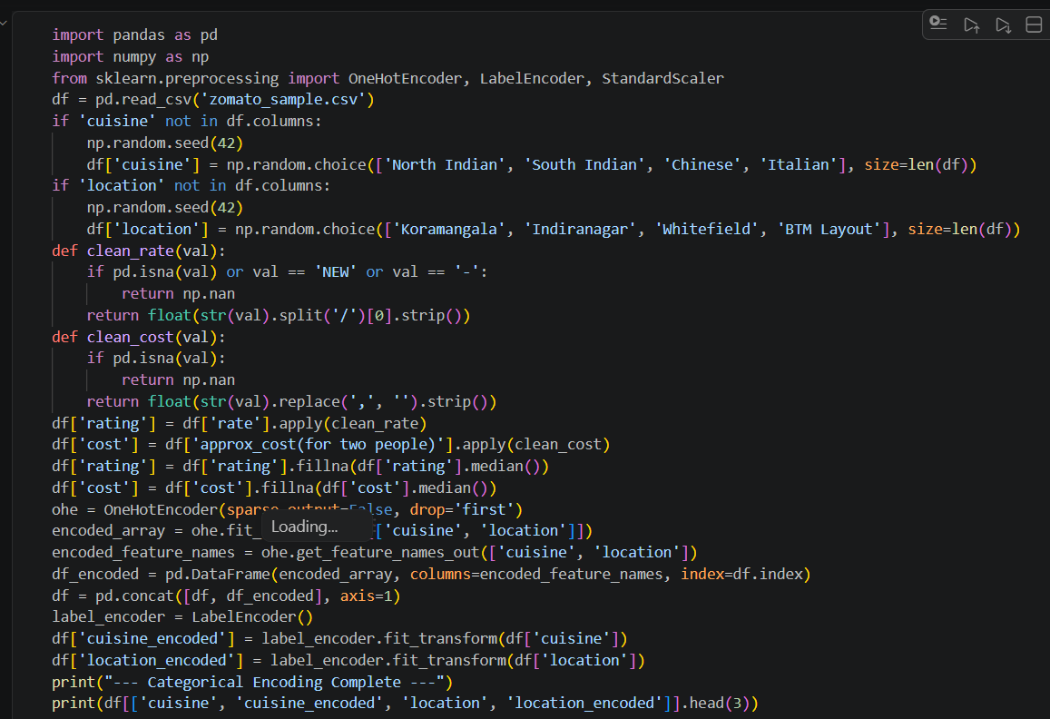
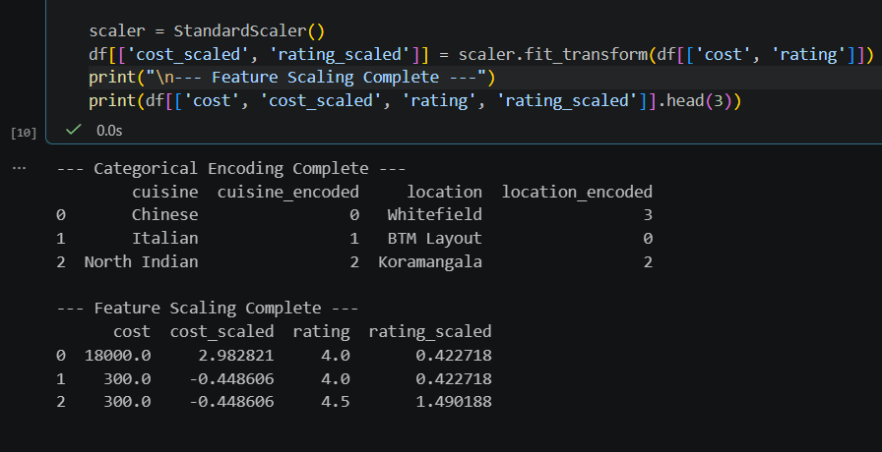

- Split the Zomato data into train and test sets (80/20), then train both a Logistic Regression and a Random Forest model to predict whether a restaurant has a rating above 4.0. Compare their ROC-AUC scores and print which model performed better.
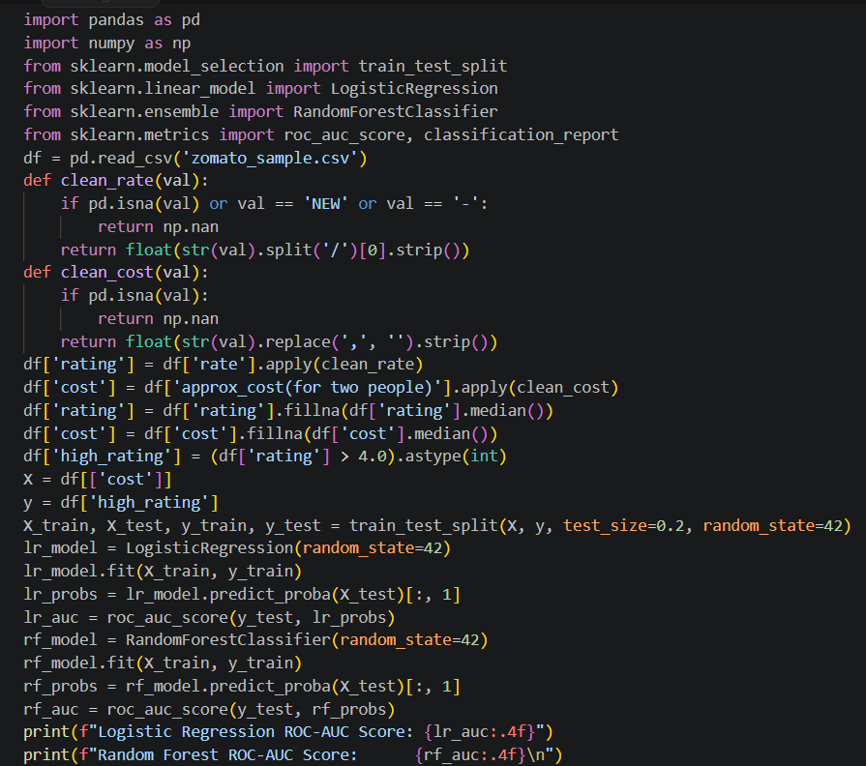
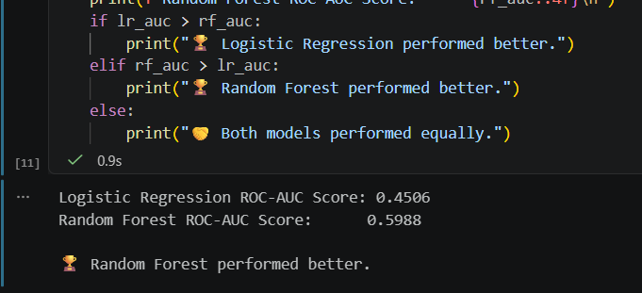

- Use SMOTE to balance the classes if the number of restaurants with rating >4.0 is much lower than those with rating <=4.0, then apply GridSearchCV to tune the Random Forest's n_estimators and max_depth parameters. Print the best parameters and ROC-AUC score. Use imblearn's SMOTE and sklearn's GridSearchCV.

